**Test Cases**

| **Input** | **Expected Output** | **Actual** **Output** | **Pass?** |
| --- | --- | --- | --- |
| number 1 = 300 number 2 = 700  operation = + | Enter two numbers between 200 and 1000 separated by a space:  300 700  Enter operation symbol (+, -, *, /):  +  Evaluation: 300 + 700 = 1000.0 | Enter two numbers between 200 and 1000 separated by a space:  300 700  Enter operation symbol (+, -, *, /):  +  Evaluation: 300 + 700 = 1000.0 | YES |
| number 1 = 300 number 2 = 200 operation = - | Enter two numbers between 200 and 1000 separated by a space:  300 200  Enter operation symbol (+, -, *, /):  -  Evaluation: 300 - 200 = 100.0 | Enter two numbers between 200 and 1000 separated by a space:  300 200  Enter operation symbol (+, -, *, /):  -  Evaluation: 300 - 200 = 100.0 | YES |
| number 1 = 200  number 2 = 700 operation = * | Enter two numbers between 200 and 1000 separated by a space:  200 700  Enter operation symbol (+, -, *, /):  *  Evaluation: 200 * 700 = 140000.0 | Enter two numbers between 200 and 1000 separated by a space:  200 700  Enter operation symbol (+, -, *, /):  *  Evaluation: 200 * 700 = 140000.0 | YES |
| number 1 = 1000 number 2 = 200 operation = / | Enter two numbers between 200 and 1000 separated by a space:  1000 200  Enter operation symbol (+, -, *, /):  /  Evaluation: 1000 / 200 = 5.0 | Enter two numbers between 200 and 1000 separated by a space:  1000 200  Enter operation symbol (+, -, *, /):  /  Evaluation: 1000 / 200 = 5.0 | YES |
| number 1 = 200 number 2 = 650 operation = % | Enter two numbers between 200 and 1000 separated by a space:  200 650  Enter operation symbol (+, -, *, /):  %  Not valid operation symbol | Enter two numbers between 200 and 1000 separated by a space:  200 650  Enter operation symbol (+, -, *, /):  %  Not valid operation symbol | YES |
| number 1 = 199 number 2 = 1001 operation = / | Enter two numbers between 200 and 1000 separated by a space:  199 1001  Both the first and the second number provided should be between 200 and 1000 | Enter two numbers between 200 and 1000 separated by a space:  199 1001  Both the first and the second number provided should be between 200 and 1000 | Yes |

**Screen Capture**

**Test Case 1:**

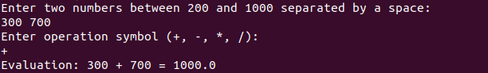

**Test Case 2:**

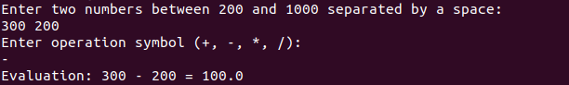

**Test Case 3:**

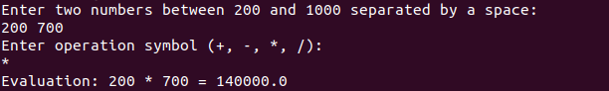

**Test Case 4:**

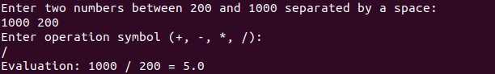

**Test Case 5:**

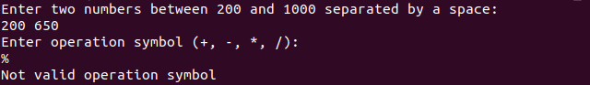

**Test Case 6:**

